Week 11 Quiz Instructions

Import the two sheets in the workbook “Gyms and Classes Excel File for Week 11 Quiz” to create an Access database which you should name Gym Database for Week 11 Quiz followed by your name. Please enforce Referential Integrity and remove any fields that don’t have any data from your database. Establish the appropriate join with your primary key in the Gyms table and the foreign key in the Members table.

Please create two queries. The first will provide a count of the members of each gym as shown below. Save this query in Access as the Gyms Query. Here is what the Gyms Query should look like:

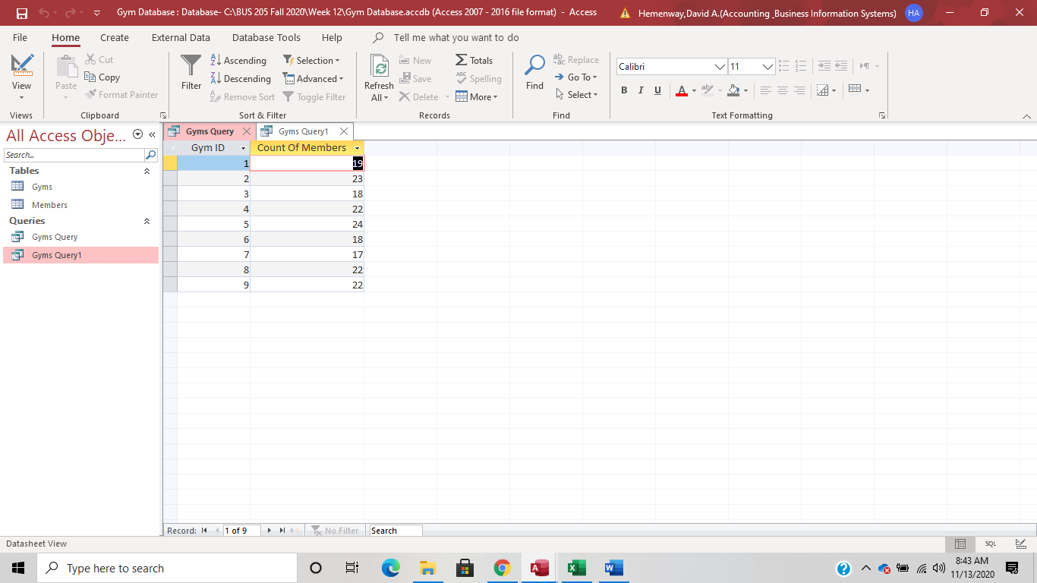

Now create a second query that should be saved as Gyms Query1 in Access. The fields should include from the Gyms table Gym ID and Gym Name. From the Members table include Name and Phone Number. Here is what the Gyms Query1 should look like:

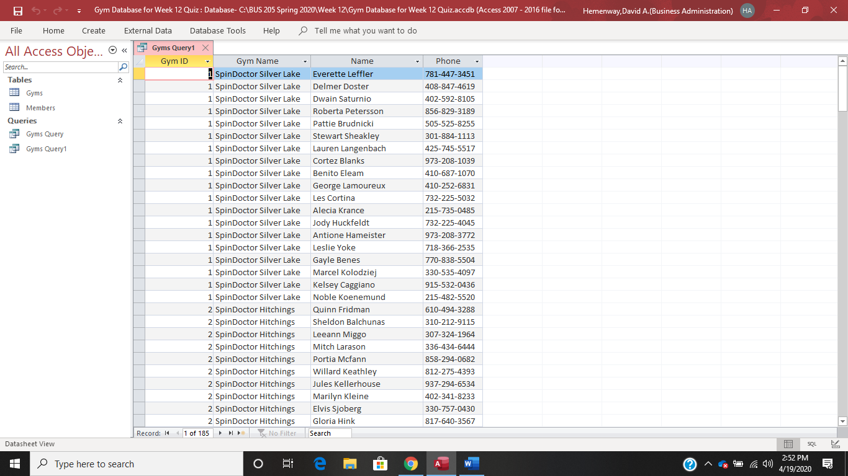

Please filter for Gym Number 8 and present only that gym’s members and phone numbers. Transfer this report to Excel and make a professional table of this information.

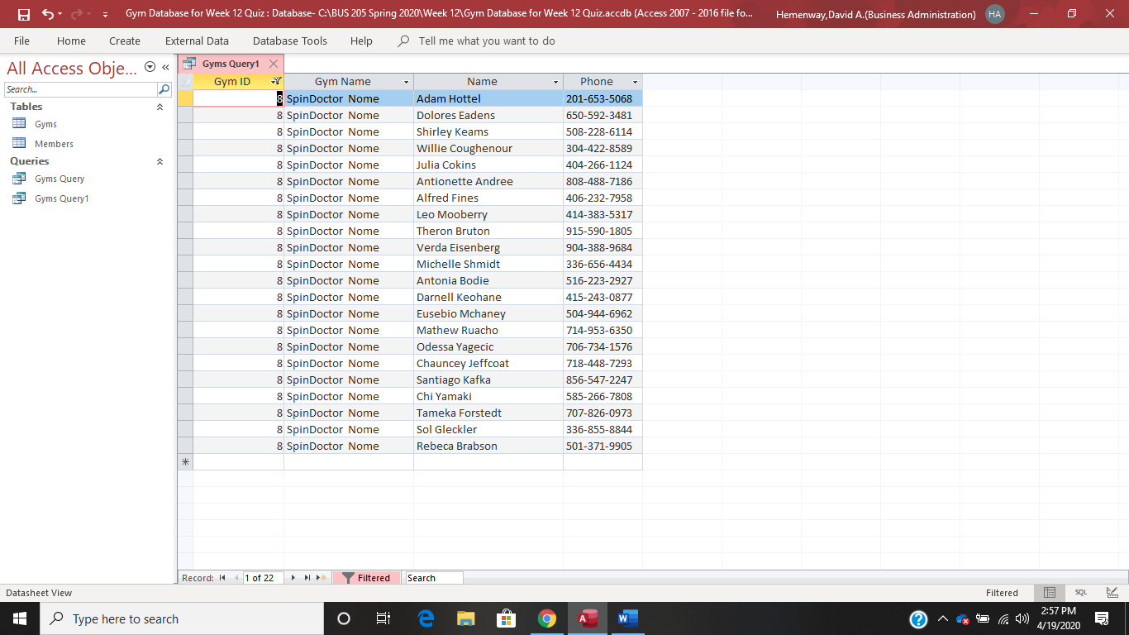

Make sure you save your Access database with the queries before you close Access and upload your database and the Excel report to Blackboard using the appropriate file name and type with your name included.